Experiment 11 – ASP.net Updation/Deletion via GridView Control and Insertion

Objective

- Familiarize you with Delete through Grid View and Insert via ASP.net web form.

Delete via GridView
Upto Step 10, follow the yellow highlighted portion only. Brown text has already been implemented by you in previous lab.
As in the last lab we used the Grid Views to display the data from an SQL table , The Grid View can also be used to delete data from that table , following exercise will demonstrate how to:

- (If not done in last lab) Create a Data base named <your rollnumber>
- (If not done in last lab) Create a table named Items and insert values in it using following queries

--Create table
Create table items
(ItemNo int,
ItemName varchar(15),
TotalUnits int
)
go

--insert values
Insert into items
values
(1,'Soap', 10 )
,(2,'Handwash', 20)
,(3,'Shampoo',5)
go
- Now Create the following procedure to Delete the Item from Items table , we will call this procedure from asp.net to delete tuples from Items table
Create PROCEDURE deleteItem
@ID int
AS
BEGIN
SET NOCOUNT ON;

DELETE FROM Items WHERE ItemNo = @ID
END

- Now in Visual Studio Create a New web project using settings as show in Figure
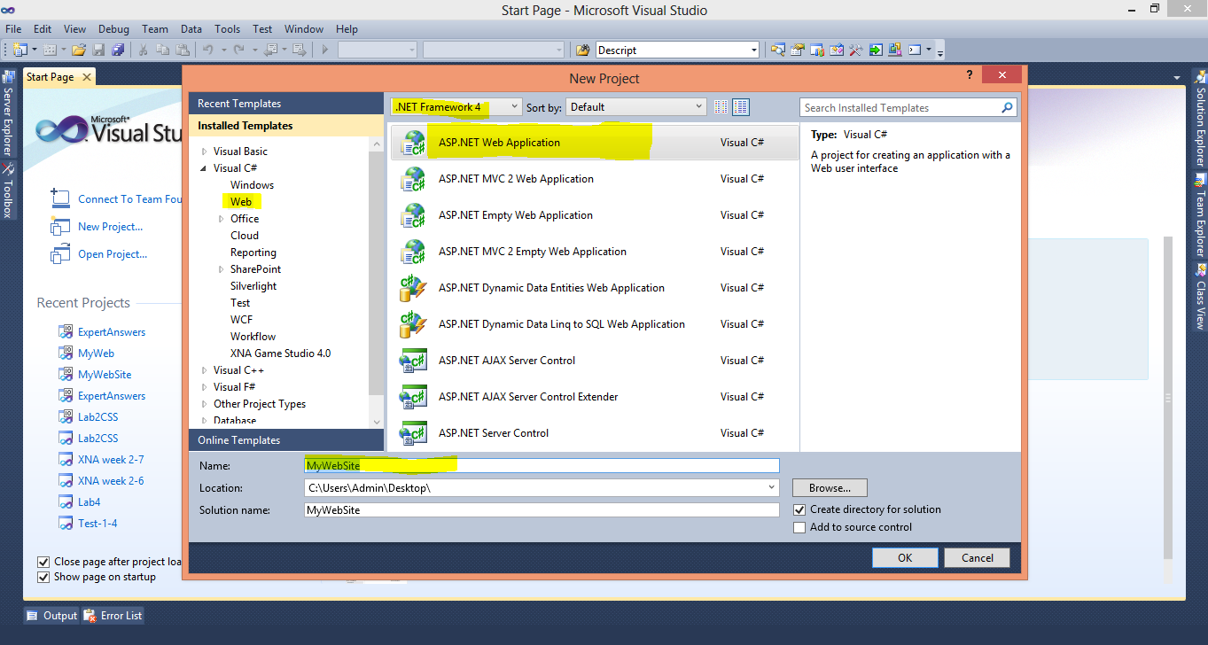

- Follow the Steps of last manual to create a Master Page (briefed as follows)
- Add The CSS files (MyCSSFile.CSS given in Resource Folder along with Manual) in your Project using Add Existing Item
- Create new Folder named Images and add all the images given in Resource/Images
- Add Master Page in you Project , using Add New Item Option from Solution Explorer Name this Master Page as MyMasterPage.Master
- Drag and Drop CSS file in header tag of Master Page, After that Open the MasterPage_Body.txt file given in Resources and Copy All the contents , Replace everything inside the Body tags of MyMasterPage with this content

- Open your Web Config file and add connectivity String in it (as done in last lab, consult lab11 Manual for details). Change the Initial Catalog to <your rollnumber> (your current DB) for this exercise

- Create DAL folder and add new myDAL.cs file in it

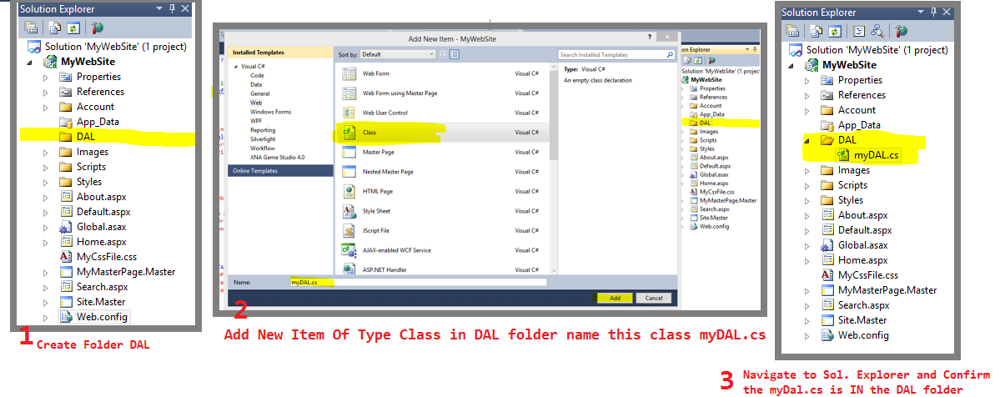

- Open the myDal.cs file and Add the Reference to Connection String plus, Name Spaces for SQL and DataSets
Using System.Data;
Using System.Data.SqlClient;

Private static readonly string connString =
System.Configuration.ConfigurationManager.ConnectionStrings["sqlCon1"].ConnectionString;

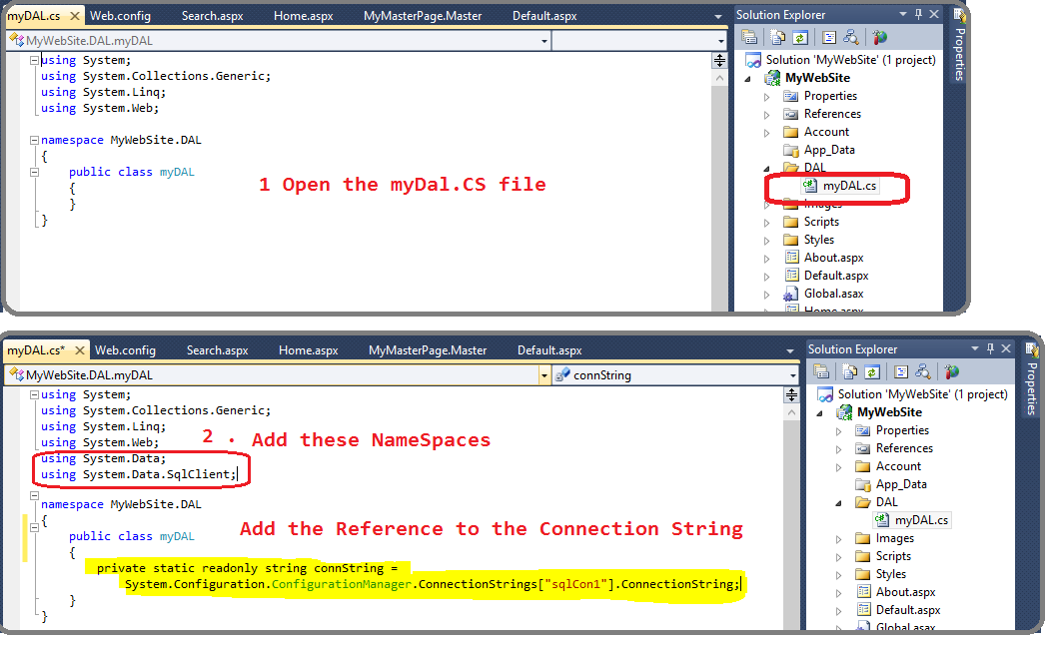

- Copy Paste following 2 functions SelectItem() and DeleteItem() in myDal.cs file

Deletion in GridView
public DataSet SelectItem() //to get the values of all the items from table Items and return the Dataset
{

DataSet ds = new DataSet(); //declare and instantiate new dataset
SqlConnection con = new SqlConnection(connString); //declare and instantiate new SQL connection
con.Open(); // open sql Connection
SqlCommand cmd;
try
{
cmd = new SqlCommand("Select * from Items", con); //instantiate SQL command
cmd.CommandType = CommandType.Text; //set type of sqL Command
using (SqlDataAdapter da = new SqlDataAdapter(cmd))
{
da.Fill(ds); //Add the result set returned from SQLCommand to ds
}
}
catch (SqlException ex)
{Console.WriteLine("SQL Error" + ex.Message.ToString()); }
finally
{con.Close(); }

return ds; //return the dataset

}
////////////////////////////////////////////////////////////////////////////
public int DeleteItem(int id)
{
SqlConnection con = new SqlConnection(connString);
con.Open();
SqlCommand cmd;
int result = 0;
try
{
cmd = new SqlCommand("deleteItem", con);
cmd.CommandType = CommandType.StoredProcedure;
cmd.Parameters.Add("@ID", SqlDbType.Int).Value = id;
result = cmd.ExecuteNonQuery();
}
catch (SqlException ex)
{ Console.WriteLine("SQL Error" + ex.Message.ToString());
}
finally
{ con.Close();

}

return result;
}

- Add New Grid in your home.aspx page with ID ItemGrid , Click the Forward Arrow button and Select Edit Columns
As shown in figure below

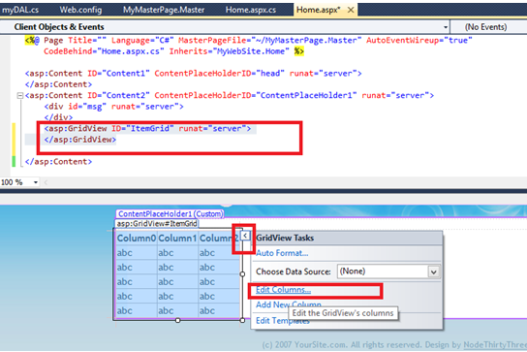
The following popup will appear, Expand CommandField and Add Edit Update, Cancel and Delete and click OK

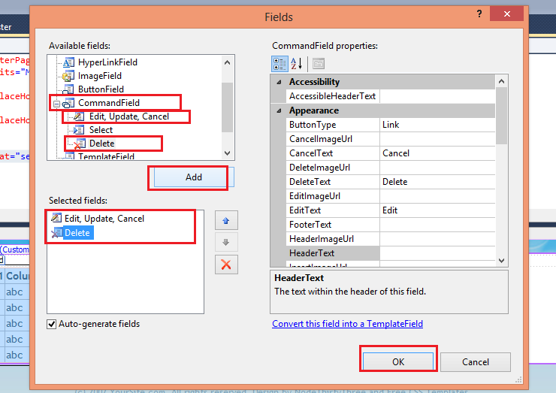

- Your Grid will have 2 new columns now

Keep the Grid selected and go to its properties (Right click on the selected Grid Arrow and go to properties), click on Small Lightening Icon, and Change the Value of Column Row Deleting to ItemGrid_RowDeleting

(Double click on the blank row to the right of Row Deleting )

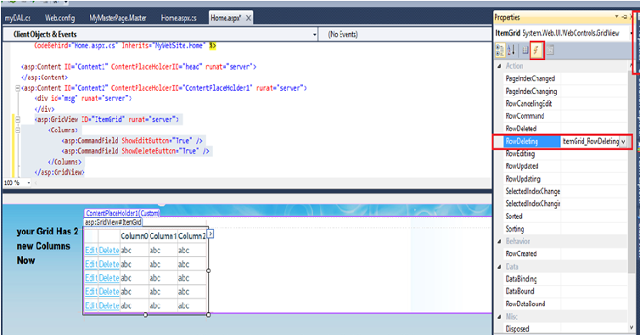

- Open the Home.aspx.cs file add the following function ItemGrid_RowDeleting

protected void ItemGrid_RowDeleting(object sender, GridViewDeleteEventArgs e)
{
myDAL objMyDal = new myDAL();
GridViewRow row = ItemGrid.Rows[e.RowIndex];
// int ItemID = Convert.ToInt32(row.Cells[2].Text.ToString());
Label itemNo = (Label)ItemGrid.Rows[e.RowIndex].FindControl("lblItemNo");
int ItemID = Convert.ToInt32(itemNo.Text.ToString());
int result = objMyDal.DeleteItem(ItemID);
if (result == -1)
{
ItemGrid.DataSource = objMyDal.SelectItem();
ItemGrid.DataBind();
}
else
{
string message = "No row deleted";
ClientScript.RegisterOnSubmitStatement(this.GetType(), "alert",

message.ToString());
}
}

Now execute your project, following results should appear in browser:

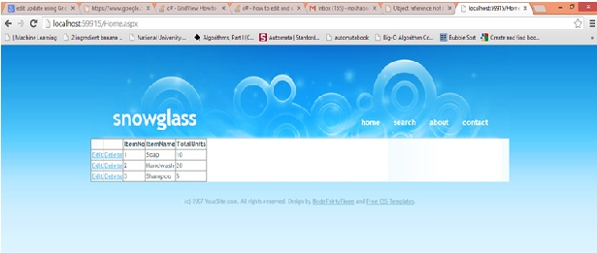

On Clicking Delete, the corresponding row will delete (check from SQL server as well)
Don’t Click Edit for now.
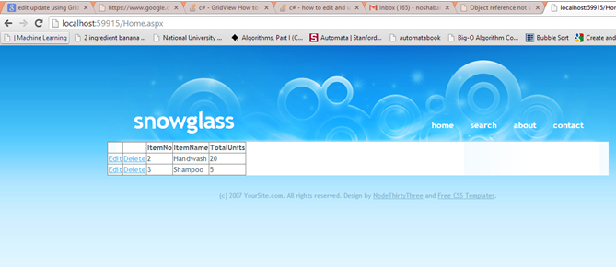

Perform Updation via GridView Control
Step1:

First we will add the following code in Home.aspx page under the “<Columns>” tag of GridView we created earlier.

<Columns>
<asp:CommandField ShowEditButton="True" />
<asp:CommandField ShowDeleteButton="True" />

<asp:TemplateField>
<ItemTemplate>
<asp:HyperLink ID="h1details" Text="Details" runat="server"
NavigateUrl='<%# "Default.aspx?ItemName="+Eval("ItemName")+"&Qty="+Eval("TotalUnits")%>'/>
</ItemTemplate>
</asp:TemplateField>

<asp:TemplateField HeaderText="ItemNo" HeaderStyle-HorizontalAlign="Left">
<EditItemTemplate>
<asp:Label ID="txtItemNo" runat="server" Text='<%# Bind("ItemNo") %>'></asp:Label>
</EditItemTemplate>

<ItemTemplate>
<asp:Label ID="lblItemNo" runat="server" Text='<%# Bind("ItemNo") %>'></asp:Label>
</ItemTemplate>

<HeaderStyle HorizontalAlign="Left"></HeaderStyle>

</asp:TemplateField>
<asp:TemplateField HeaderText="ItemName" HeaderStyle-HorizontalAlign="Left">
<EditItemTemplate>
<asp:TextBox ID="txtItemName" runat="server" Text='<%# Bind("ItemName") %>'></asp:TextBox>
</EditItemTemplate>
<ItemTemplate>
<asp:Label ID="lblItemName" runat="server" Text='<%# Bind("ItemName") %>'></asp:Label>
</ItemTemplate>
<HeaderStyle HorizontalAlign="Left"></HeaderStyle>
</asp:TemplateField>
<asp:TemplateField HeaderText="TotalUnits" HeaderStyle-HorizontalAlign="Left">
<EditItemTemplate>
<asp:TextBox ID="txtTotalUnits" runat="server" Text='<%# Bind("TotalUnits") %>'></asp:TextBox>
</EditItemTemplate>
<ItemTemplate>
<asp:Label ID="lblTotalUnits" runat="server" Text='<%# Bind("TotalUnits") %>'></asp:Label>
</ItemTemplate>
<HeaderStyle HorizontalAlign="Left"></HeaderStyle>
</asp:TemplateField>
</Columns>

As shown in figure below
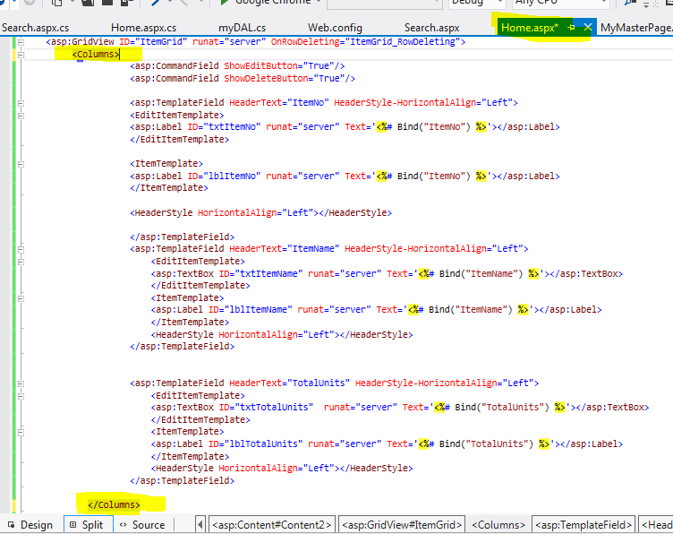

Now set the “EnableViewState” and “AutoGenerateColumns” properties of the Grid View as follows: 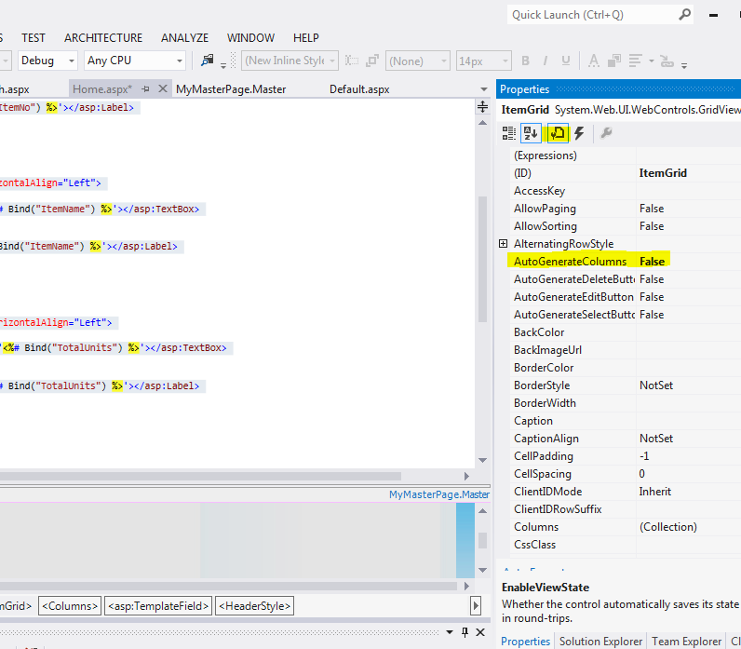

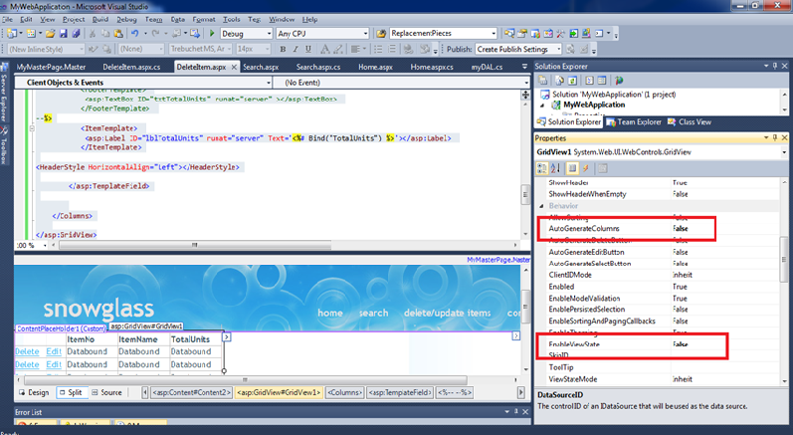

Step2:

Now we will set up all the events in our .aspx page which we will require for implementing Edit functionality as shown in the following screen shot:

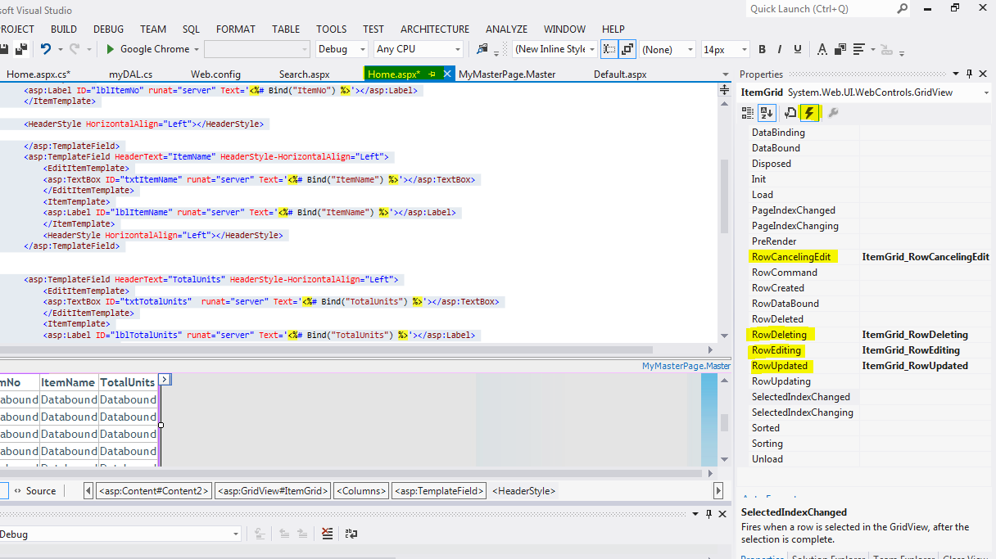

Step3:

Now we are set to move to the BLL (Business Logic layer)of this page which is the Home.aspx.cs. There we will implement all the above create event handling functions.

Following are the functions which you have to copy/paste as well against all the event handling definitions created above: (Don’t delete function code of ItemGrid_RowDeleting)

public void LoadGrid()
{
myDAL objMyDal = new myDAL();
ItemGrid.DataSource = objMyDal.SelectItem();//seting data source for this Grid
ItemGrid.DataBind(); //bind the data source to this grid
}
protected void ItemGrid_RowCancelingEdit(object sender, GridViewCancelEditEventArgs e)
{
ItemGrid.EditIndex = -1;
LoadGrid();

}

protected void ItemGrid_RowEditing(object sender, GridViewEditEventArgs e)
{
ItemGrid.EditIndex = e.NewEditIndex;
LoadGrid();

}
protected void ItemGrid_RowUpdating(object sender, GridViewUpdateEventArgs e)
{
GridViewRow row = (GridViewRow)ItemGrid.Rows[e.RowIndex];
//==== getting the value from the respective controls=====
Label itemNo = (Label)ItemGrid.Rows[e.RowIndex].FindControl("txtItemNo");
TextBox ItemName = (TextBox)ItemGrid.Rows[e.RowIndex].FindControl("txtItemName");
TextBox TotalUnits = (TextBox)ItemGrid.Rows[e.RowIndex].FindControl("txtTotalUnits");
//========================================================
int itemNoValue = Convert.ToInt32(itemNo.Text.ToString());
string itemNameValue = ItemName.Text.ToString();
int totalUnits = Convert.ToInt32(TotalUnits.Text.ToString());

//=====updating the newly entered values in database====
myDAL objMyDal = new myDAL();
objMyDal.UpdateItem(itemNoValue, totalUnits, itemNameValue);
//======================================================
ItemGrid.EditIndex = -1;
LoadGrid();

}
Step 4:
Now moving on to the DAL layer of our application, we will have to create function for Update/Edit functionality. For that copy paste the following function in to you myDAL.cs file.
public int UpdateItem(int id, int totalUnits, string itemName)
{
SqlConnection con = new SqlConnection(connString);
con.Open();
SqlCommand cmd;
int result = 0;
try
{
cmd = new SqlCommand("UpdateItem", con);
cmd.CommandType = CommandType.StoredProcedure;
cmd.Parameters.Add("@itemNo", SqlDbType.Int).Value = id;
cmd.Parameters.Add("@itemname", SqlDbType.VarChar).Value = itemName;
cmd.Parameters.Add("@totalUnits", SqlDbType.Int).Value = totalUnits;
result = cmd.ExecuteNonQuery();
}
catch (SqlException ex)
{
Console.WriteLine("SQL Error" + ex.Message.ToString());
}
finally {
con.Close();
}
return result;
}
When Copy paste for step 3, you will be having error on the code where update is written, it will be gone once you paste code for update item or in other words step 4.
Step 5:

Execute the below script on your database so that the required procedure for editing functionality is created:

CREATE PROCEDURE UpdateItem
@itemNo int, @itemname varchar(100), @totalUnits int
AS
BEGIN SET NOCOUNT ON;
Update items set ItemName=@itemname, TotalUnits=@totalUnits
where ItemNo=@itemno;
END

Perform insertion

- Change the Home.aspx page to look as follows: (Don’t execute now. Use split view )
Code is given below. Replace below code with all code of the Home.aspx
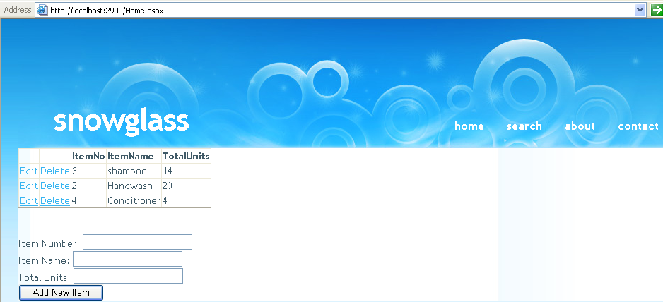
<%@ Page Title="" Language="C#" MasterPageFile="~/MyMasterPage.Master" AutoEventWireup="true" CodeBehind="Home.aspx.cs" Inherits="MyWebSite.Home" %>
<asp:Content ID="Content1" ContentPlaceHolderID="head" runat="server">
</asp:Content>
<asp:Content ID="Content2" ContentPlaceHolderID="ContentPlaceHolder1" runat="server">
<asp:GridView ID="ItemGrid" runat="server" OnRowDeleting="ItemGrid_RowDeleting" AutoGenerateColumns="False" EnableViewState="False" OnRowCancelingEdit="ItemGrid_RowCancelingEdit" OnRowEditing="ItemGrid_RowEditing" OnRowUpdating="ItemGrid_RowUpdating">
<Columns>
<asp:CommandField ShowEditButton="True" />
<asp:CommandField ShowDeleteButton="True" />

<asp:TemplateField>
<ItemTemplate>
<asp:HyperLink ID="h1details" Text="Details" runat="server"
NavigateUrl='<%# "Default.aspx?ItemName="+Eval("ItemName")+"&Qty="+Eval("TotalUnits")%>'/>
</ItemTemplate>
</asp:TemplateField>

<asp:TemplateField HeaderText="ItemNo" HeaderStyle-HorizontalAlign="Left">
<EditItemTemplate>
<asp:Label ID="txtItemNo" runat="server" Text='<%# Bind("ItemNo") %>'></asp:Label>
</EditItemTemplate>

<ItemTemplate>
<asp:Label ID="lblItemNo" runat="server" Text='<%# Bind("ItemNo") %>'></asp:Label>
</ItemTemplate>

<HeaderStyle HorizontalAlign="Left"></HeaderStyle>

</asp:TemplateField>
<asp:TemplateField HeaderText="ItemName" HeaderStyle-HorizontalAlign="Left">
<EditItemTemplate>
<asp:TextBox ID="txtItemName" runat="server" Text='<%# Bind("ItemName") %>'></asp:TextBox>
</EditItemTemplate>
<ItemTemplate>
<asp:Label ID="lblItemName" runat="server" Text='<%# Bind("ItemName") %>'></asp:Label>
</ItemTemplate>
<HeaderStyle HorizontalAlign="Left"></HeaderStyle>
</asp:TemplateField>
<asp:TemplateField HeaderText="TotalUnits" HeaderStyle-HorizontalAlign="Left">
<EditItemTemplate>
<asp:TextBox ID="txtTotalUnits" runat="server" Text='<%# Bind("TotalUnits") %>'></asp:TextBox>
</EditItemTemplate>
<ItemTemplate>
<asp:Label ID="lblTotalUnits" runat="server" Text='<%# Bind("TotalUnits") %>'></asp:Label>
</ItemTemplate>
<HeaderStyle HorizontalAlign="Left"></HeaderStyle>
</asp:TemplateField>
</Columns>
</asp:GridView>

<p> item number
<asp:TextBox runat="server" ID="TxtItmNo" Text="" ></asp:TextBox>
</p>
<p>item name
<asp:TextBox runat="server" ID="TxtItmName" Text="" Height="20px" style="margin-left: 14px; margin-top: 6px" ></asp:TextBox>
</p>

<p>total units
<asp:TextBox runat="server" ID="TxtUnits" Text="" style="margin-left: 18px" ></asp:TextBox>
</p>
<asp:Button runat="server" ID="buttonadd" Text="add new items" OnClick="insrtItem_Click" />
</asp:Content>

Please ensure that the ID property of the three text fields are set as TxtItmNo , TxtItmName and TxtUnits respectively.

On click of the “Add New Item” button copy the following code in Home.aspx.cs
(shows error on insert, will be removed after next step)
protected void insrtItem_Click(object sender, EventArgs e)
{
int itemNoValue = Convert.ToInt32(TxtItmNo.Text.ToString());
string itemNameValue = TxtItmName.Text.ToString();
int totalUnits = Convert.ToInt32(TxtUnits.Text.ToString());

//=====updating the newly entered values in database====
myDAL objMyDal = new myDAL();
objMyDal.insertItem(itemNoValue, totalUnits, itemNameValue);

LoadGrid();
}

In myDAL.cs file Add the following function:
public int insertItem(int id, int totalUnits, string itemName)
{
SqlConnection con = new SqlConnection(connString);
con.Open();
SqlCommand cmd;
int result = 0;
try
{
cmd = new SqlCommand("InsertItem", con);
cmd.CommandType = CommandType.StoredProcedure;
cmd.Parameters.Add("@itemNo", SqlDbType.Int).Value = id;
cmd.Parameters.Add("@itemname", SqlDbType.VarChar).Value = itemName;
cmd.Parameters.Add("@totalUnits", SqlDbType.Int).Value = totalUnits;

result = cmd.ExecuteNonQuery();
}
catch (SqlException ex)
{
Console.WriteLine("SQL Error" + ex.Message.ToString());
}
finally
{
con.Close();
}

return result;
}//end of insert function

Create the following procedure in SQL Server 2012
CREATE PROCEDURE InsertItem
@itemNo int,
@itemname varchar(100),
@totalUnits int
AS
BEGIN
SET NOCOUNT ON;
insert into items values(@itemno, @itemname, @totalUnits );
END

Build and run your project. On giving the values and clicking the “Add New Item” button a new item should get inserted.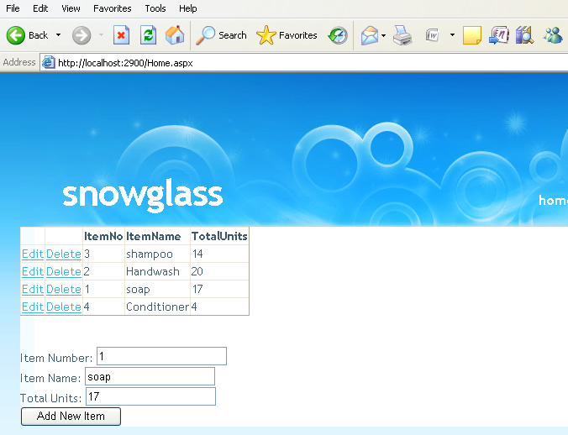

Post Lab
Make another page which has a search bar in it. The searched item can be updated/deleted.

